Voice Activated Automatic Self Folding Dining Table

Dining tables are used only during lunch and dinner, yet they occupy large spaces in a room for the entire duration of day and night. There are some folding dining tables but manually dragging the dining tables, then unfolding and folding dining tables manually 2 times a day is a strenuous task.

Well what if the table could automatically move itself to the centre of the room and then unfold itself when you tell it to? Also automatically fold itself and move itself to the corner of the room to act as a side table on your command. Well such tables are not just a future concept now that we design an automatic dining table with the exact functioning as mentioned above.

The Automatic self-folding dining table provides following advantages including:
- Only occupies 1/3rd of the space when not in use
- Automatic Unfolding on button Press
- Self-Folding on a Button Press
- Can Move itself to Room Centre before Unfolding
- Obstacle Detection before Opening for Safety
- Fully Automatic operation, truly Modern automatic furniture

The self-folding and unfolding dining table makes use of dual motor drive along with IR Sensors and dual motor folding and unfolding mechanism to achieve this operation. The system is integrated with a controller based speech recognition system to enable the open and close operation via spoken commands.
When user instructs then dining table to open the command is captured by the controller mic and processed. Now the system checks for obstacles on both sides o divide which side to open on. If the user command said open the table half, the machine will only open half table on the open side. It user command says open full then the table will move itself on the pen side and then open both the sides to serve as a full dining table.
This unfolding processes activates the motorized mechanism that uses a geared arrangement to move a connected rod to drive another support rod with a wheel arrangement to push the sides of the table into a horizontal alignment parallel to the centre table plate. This mechanism allows to open the table on both or any one side as needed.
The same mechanism is used to unfold the table and move back to the wall itself after folding so that it frees up the space. Also the unfolding happens simply on users commands, all user needs it to ask the dining table to close itself.

Components:
- DC Motors
- Raspberry Pi
- Shafts
- Gears
- Connecting Rods
- Proximity Sensors
- Hinges
- Wheels
- Castor wheels
- Resistors Capacitors
- Diodes & transistors
- PCB Board
- Motor Mounts
- Motor Drivers
- Outer Frame
- Couplings
- Switches
- Electrical & Wirings
- Mounts and Joints
- Supporting Frame
- Screws and Fittings

Applications:
- Homes and offices
- Lounge and Restaurants
- Hotels, Malls and Food Joints

Advantages:
- Only occupies 1/3rd of the space when not in use
- Automatic Unfolding on button Press
- Self-Folding on a Button Press
- Can Move itself to Room Centre before Unfolding
- Obstacle Detection before Opening for Safety
- Fully Automatic operation, truly Modern automatic furniture

Disadvantages:
- Cannot check if utensils are still on table before unfolding
- Needs Power Supply
Block Diagram:

Front View
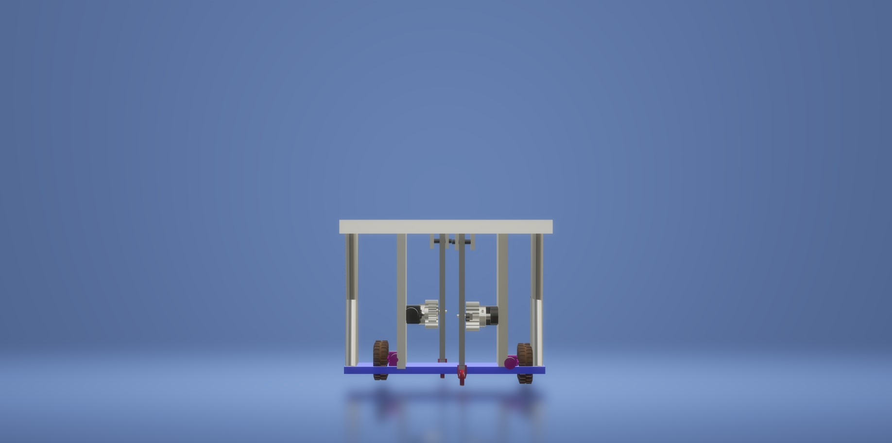

Side View

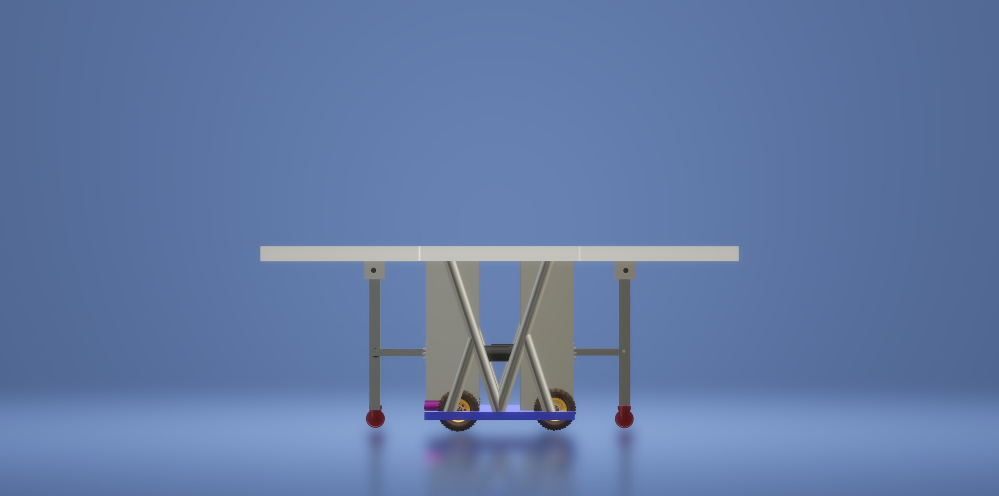

3D View
